Math 8 Name_____________________

Functions Test Review

What is a relation? _________________________________________________________
Domain: the set of _____________________
Range: the set of _____________________

A relation can be represented in the following ways:
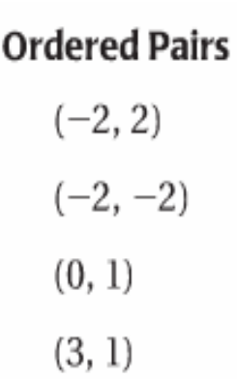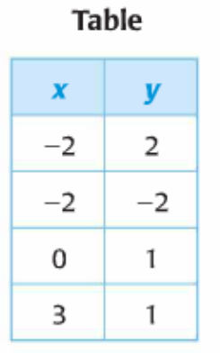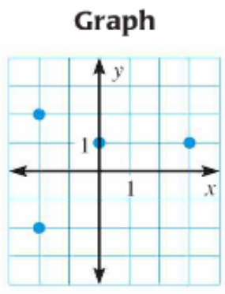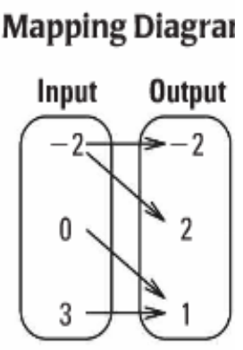

Example 1:
Consider the relation given by the following ordered pairs: (-2, -3), (-1, 1), (1, 3), (2, -2), and (3, 1)
- Identify the domain and range:
Domain=
Range =
- Represent the relation using a graph and a mapping diagram:
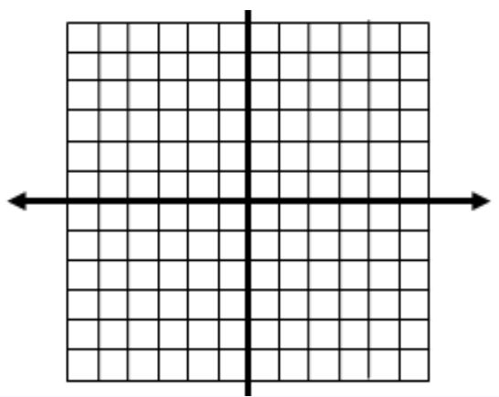
Mapping Diagram
Input Output

Is the relation a function? Explain.
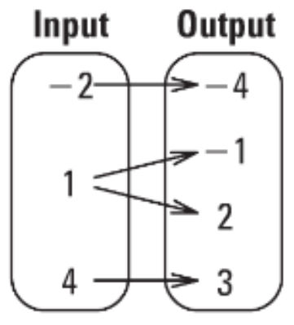
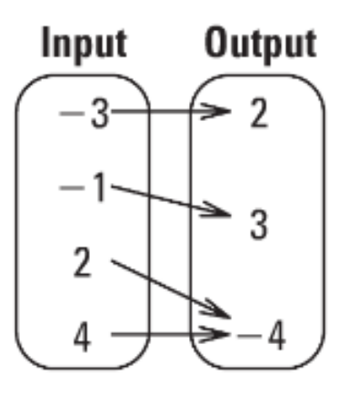
Function? ________ Function? _________

Example 2:
Consider the relation given by the following ordered pairs: (-4, 3), (-2, 1), (0, 3),
(1, -2), and (-2, -4)
- Identify the domain and range:
Domain=
Range =
- Represent the relation using a table and a mapping diagram:
x
y
Input Output

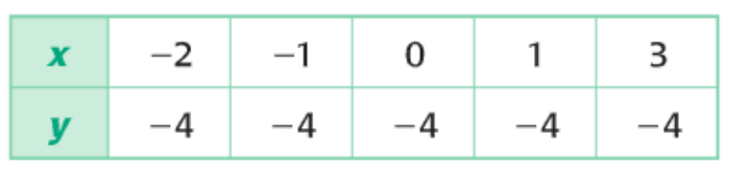
Example 3:
Is the following relation a function? Why or why not?

Find the indicated values for g(x) = 3x+1

- g(2) 2. g(0) 3. g(1/3)

4. g(-5) 5. g(-10) 6. g(50)

Find the indicated values by using the graph.
7. h(-4) 8. h(-3) 9. h(-2)

10. h(-1) 11. h(0) 12. h(1)

Graphing Linear Functions
Example: y = 3x – 5
x is called the __________________ and y is called the _______________
The ordered pair (x, y) is called a ________________ of an equation if substituting x and y into the equation produces a _______________________.
- Is the ordered pair (2, 1) a solution of y = 3x – 5?

- Is (-3, 2) a solution of y = x + 1?

Graphing Equations Using Table of Values
x | y
Graph the equation y = 3x – 5
- Construct a table of values
- Plot the points.
- Connect the points with a line

x | y
Graph the equation
- Construct a table of values.
- Choose x-values that would
create integer y-values
- Connect the points with a line

Graphing Non-Linear Functions
x | y
Graph the equation y = $x^{2}$
- Construct a table of values
- Plot the points
- Connect the points with a U.

x | y

Graph the equation x = $y^{2}$
- Construct a table of values.
- Choose y-values.
Find the x-value.
- Connect with a sideways U.

Graph the equation xy = $6$
x | y
-6
-3
-2
2
3
6

- Construct a table of values.
- Choose y-values.
Find the x-value.
- Connect with a sideways U.

Linear Functions can be written in the form ___________________. The graph of a linear function is a __________.
Function Notation of a linear function is:
f(x) = mx + b (replace “y” with “f(x)”)
f(x) is read “the value of f at x” or “f of x”
**This means, what output do you get when you plug in an input of x**
Circle if the relation is linear or non-linear. Then evaluate the function.
- f(-4) = _____ linear non-linear

- f(-4) = _____ linear non-linear

- $f\left(x\right){=x}^{2}$ f(-3)= __________ linear non-linear
- $f\left(x\right){=x}^{3}$ f(-2) = _________ linear non-linear
- $k\left(x\right){=x}^{2}+1$ k(5) = __________ linear non-linear
- $g\left(x\right){=x}^{3}-5$ g(3) = ___________ linear non-linear
- $m\left(x\right)=2$ m(3) = ___________ linear non-linear
- $m\left(x\right)=2x-7$ m(-3) = ___________ linear non-linear
- $m\left(x\right)=$ $\frac{1}{3}x-2$ m(10) = ___________ linear non-linear
- $m\left(x\right)=\frac{1}{4}x-2$ m(40) = ___________ linear non-linear
- $m\left(x\right)=\frac{1}{5}x-2$ m(-50) = ___________ linear non-linear
- $m\left(x\right)=\frac{1}{6}x-2$ m(-18) = ___________ linear non-linear
- $m\left(x\right){=x}^{2}-1$ m(-5) = ___________ linear non-linear
- $b\left(x\right){=2x}^{2}+1$ b(4) = ___________ linear non-linear
- $m\left(x\right)={-3x}^{2}+1$ m(9) = ___________ linear non-linear
- $c\left(x\right){=x}^{2}+12$ c(7) = ___________ linear non-linear
- $m\left(x\right)=-4x^{2}-1$ m(-6) = ___________ linear non-linear
- $m\left(x\right){=x}^{3}+1$ m(1) = ___________ linear non-linear
- $r\left(x\right){=x}^{3}-11$ r(2) = ___________ linear non-linear
- $m\left(x\right){=x}^{-1}+1$ m($\frac{1}{2}$) = ___________ linear non-linear
- $m\left(x\right){=x}^{-1}-1$ m(3) = ___________ linear non-linear
- $m\left(x\right)=x^{-1}-10$ m($\frac{1}{3}$)) = ___________ linear non-linear
Write a paragraph about functions. Use the following words: input, output, range, domain, relation, function, order pairs, graph, linear, equation, non-linear, mapping and table.

