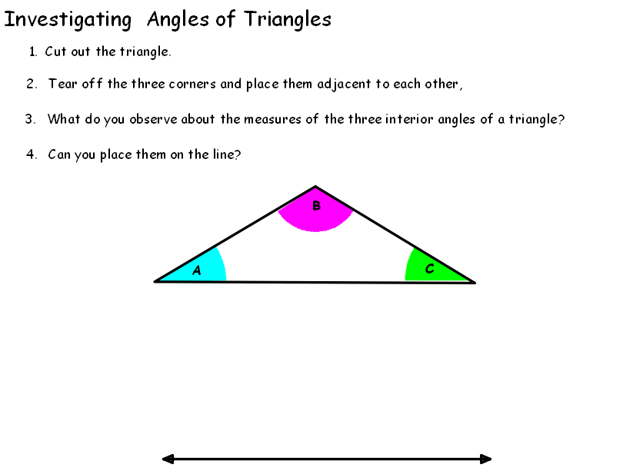

Cut out entire triangle then tear off angle corners

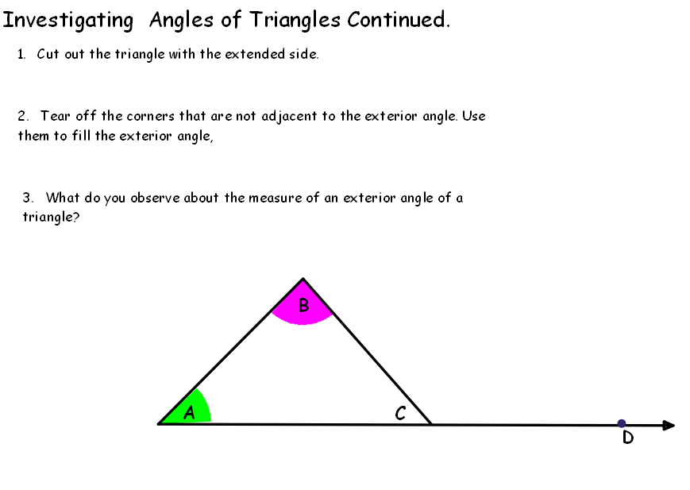

Cut here then tear off angle corners