Math 8 Name ______________________________
Review: Intro to Functions Date __________

Consider the relation f defined by {(7, 5), (1, -1), (3, 2), (7, 2)} for problems 1-5.

- Name the domain. 1. _______________
- Name the range. 2. _______________
- Is this relation a function? 3. _______________
- Explain your answer. 4. _________________________________
- Create a mapping of the relation. 5.

Use the functions $f\left(x\right)=3x-7 \text{and }g\left(x\right)= -4x$ to answer problems 6-8.

- $f(6)$ 6. _______________
- $g\left(-5\right)$ 7. _______________
- $f\left(-1\right)+ g(5)$ 8. _______________
Determine whether each relation is a function. Write ‘yes’ or ‘no’ in the blank.

- ______________ 10. __________________ 11. ______________
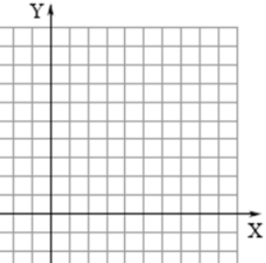
x | f(x)
-3 | 4
-4 | 1
-3 | 0
5 | 1
8 | 4

