Math 8 Investigation Name _____________________________
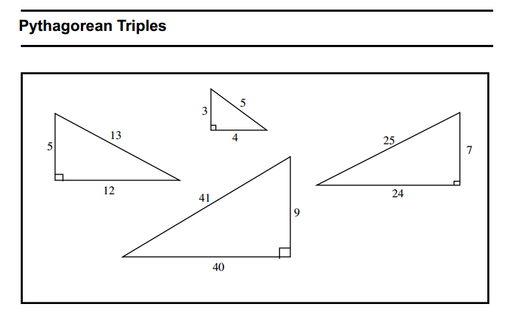
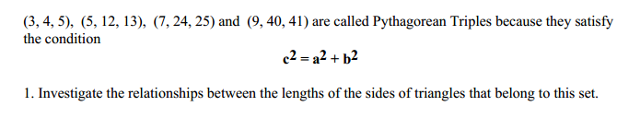
- In the space below show that 3, 4, 5 is a Pythagorean Triple.

b. In the space below show that 5, 12, 13 is a Pythagorean Triple.

c. In the space below show that 7, 24, 25 is a Pythagorean Triple.

d. In the space below show that 9, 40, 41 is a Pythagorean Triple.

#1 . One minute Timed Write

#1 . One minute Timed Write

