**Name: ________________________**

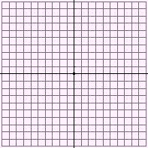**Prerequisite Skill Graphing Linear Equations**

**MCC8.G.3 Describe the effect of dilations, translations, rotations and reflections on two-dimensional figures using coordinates.**

1.  Graph y=3 2. Graph x= -2



1. Graph x = 3 4. Graph y = -5