Dec 2 – Dec 6 Homework NWNC Name ____________________________

Monday 30 minutes of Compass __________________________________ Parent Signature

Tuesday 1-9 Wednesday 10-21 Study for Quiz tomorrow Thursday 22-27

Directions: Are the relations functions? If not, explain why.
- {(4, 7), (8, 11), (4, 9), (8, 13)}

- {(-3, 0), (-2, 0), (-1, 0), (0, 0), (1, 1)}

- {(6, 25), (12, 35), (18, 45), (24, 55)}

- {(2, 4), (3, 5) (2, 6), (7, 9)}

- The amount of bananas you buy at a store for $.85 per pound.

- The amount of carrots that you buy at a store for $.29 per pound.

- The steady price increase of a bus ticket over time.

Directions: Answer each question about functions.
- Evaluate the function when the domain is {-3, -1, 1, 3}.

- Evaluate the function when the domain is {-10, -5, 0, 5, 10}.

- Evaluate the function when the domain is {5, 6, 7, 8, 9}.

- Evaluate the function when the domain is {1, 2, 3, 4, 5}.

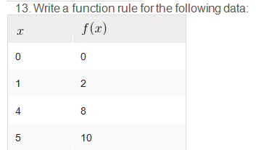
Directions: Write function rules.
- Write a function rule for the following data.
9 | 27
11 | 33
15 | 45
16 | 48
Directions: Solve the following problem.
- Sandwich cost $3.45 each. Write a function rule for the cost, , for a number of sandwiches, .

- Now, find the cost of 3, 6, and 9 sandwiches.

Directions: Is the graph a function? Explain your reasoning.

- 17. 18.

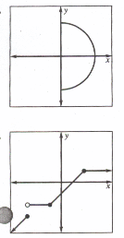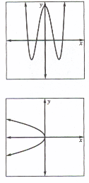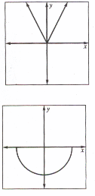
20.
21.
19.

Directions: Write the mathematical representation for each verbal expression.
22. Three times a number increased by 8
23. Six times the difference of a number and 7
24. The product of two and a number is 142.
25. The quotient of the sum of a number and 8 and 5 is equal to 17.
26. The quotient of 13 and a number
27. Nine less than two times a number is twenty.

