Distance Formula Name______________

Plot the points (3,0) and (0,4).

What is the rise of the line?

What is the run of the line?

What is the slope of the line?

What is the formula for run?

What is the formula for rise?
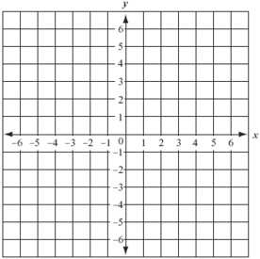
Draw a right triangle using the points (3,0) and (0,4).

What is a?

What is b?

Do you see a relationship between a, b and the rise and run?

How do you find c?

What is the distance formula?

